$cat
$cat -echos the statement in the next line
$cat file.txt -echos the file if it is in the form of txt file else,gives error!!

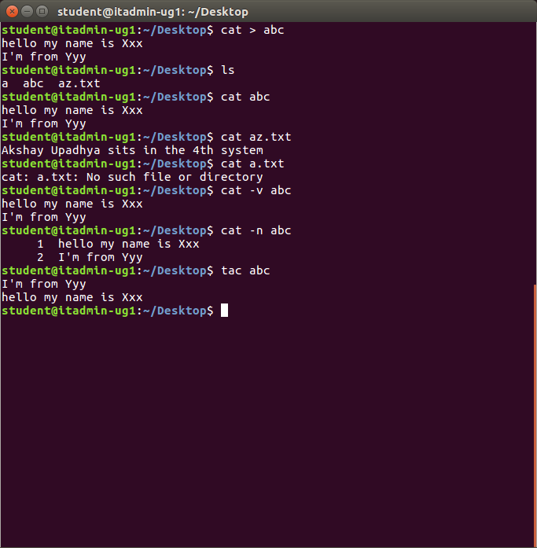
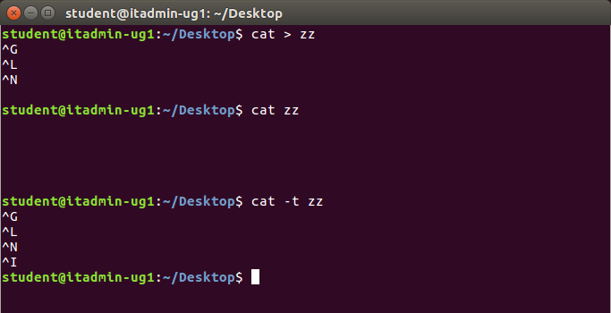

$cp // Command

the below picture shows cp command executed for normal files,hidden files
copying fronm one place(Directory) to another
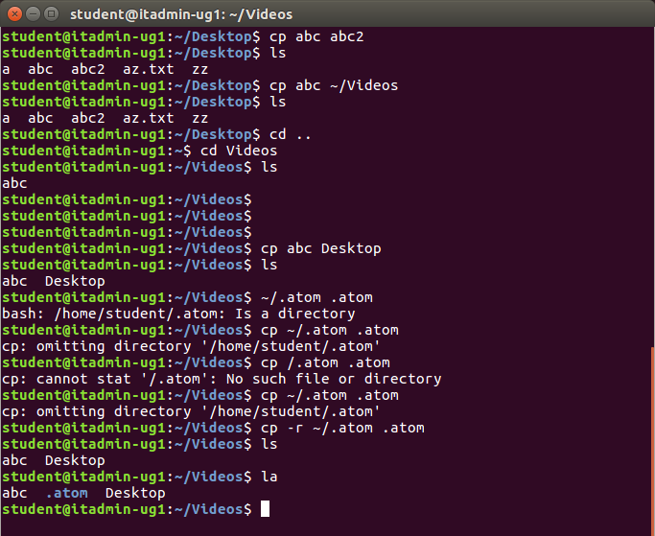
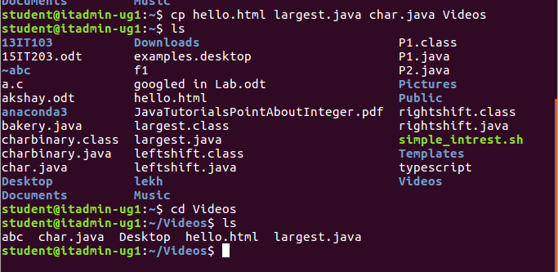
the above pic illustrates how to copy multiple files at once

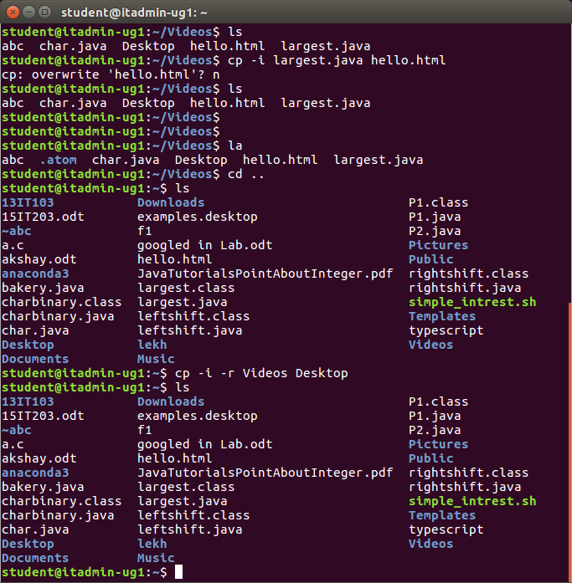
the above pic shows how to copy directories

If the directory doesnot exist then
it’ll create the directory and copy the contents
if permission is not there to create the
“ cant create a directory :Permission denied ” -if permission is not there

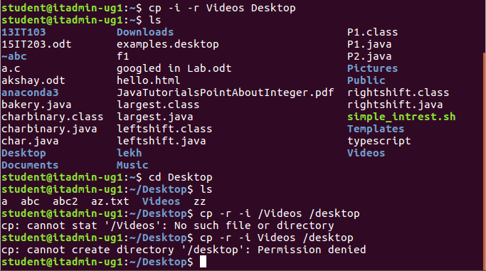
$rm

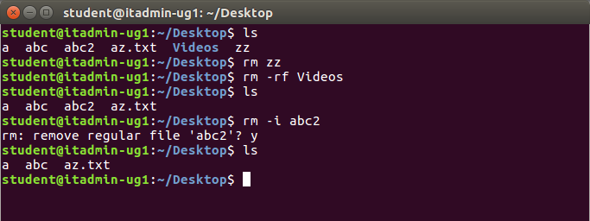

$more
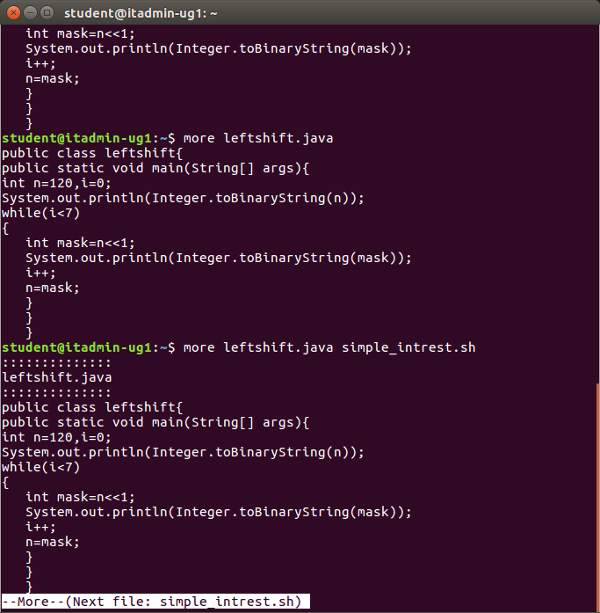

$od

